**How to Create Reports and Dashboards in Salesforce**



Salesforce has diligently worked for the last 17 years to build a brand name while successfully showcasing growth, retaining customers with service and value, creating a sense of collectiveness amongst customers and stakeholders, making it a brand to be reckoned with in the CRM space. Here’s [**why Businesses Love Salesforce!**](https://www.appseconnect.com/things-businesses-love-about-salesforce/)

So, moving on…

**What is a Report?**

A Report is a document which contains data in an organized tabular or graphical format prepared for a certain period of time.

Salesforce report is a list of data generated based on the criteria defined. Reports have access to Salesforce data and can be used to display in terms of rows and columns. As Reports are very confidential, their accessibility plays an important role. Salesforce has control over reports based on the folder in which they are created. The folders can be public, shared, hidden, Read-only and Read/write etc. In a business process, there are many areas where there is a need for a report to have a better understanding.

**For Example:** Consider a business scenario in which a company ‘ABC’ manages ‘Real Estate’ process.  ‘ABC’ has ‘Properties’ which are available for “Sell or Rent” and ‘Prospects’ are the customers who own the properties. Both ‘Properties’ and ‘Prospects’ plays a major role in companies revenue. So to maximize the business process and to know stats, there is a need for preparing reports like – How many properties are sold in a year, Top properties sold based on prices, Top active prospects in a year etc. which helps you in understanding and forecasting the business process. Now, we will create a Report on sold properties based on price(Descending Order). Before creating the report let’s have a quick look into types of Reports in Salesforce.

**Types of Reports in Salesforce:**

Salesforce has a provision for four types of reports

**1. Tabular:**

This is a basic and simple form of a report which displays records in a tabular format. Consider the above example, it shows all the Property records in a row by row tabular format as shown below.

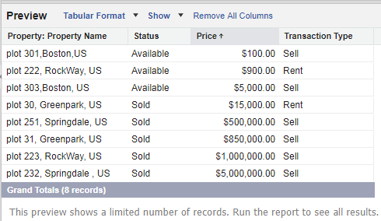

**2. Summary:**

Summary reports are mostly used to group rows of data. “Group field” plays an important role in the summary report. Grouping is done based on the value of a selected field. Consider the above example, a property object has a custom field ‘Status’ of pick list type and has two values i.e. (Available, Sold). By selecting the status field as grouping field, a summary report is generated in two groups, one is an ‘Available’ group and the second one is ‘Sold’ group as shown below. Grouping in Summary is on a row basis. You can also create subgrouping in summary reports.[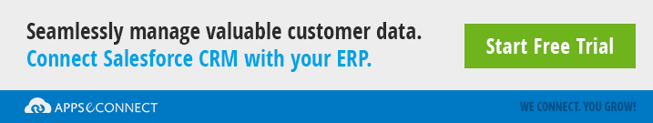](https://www.appseconnect.com/free-trial/)

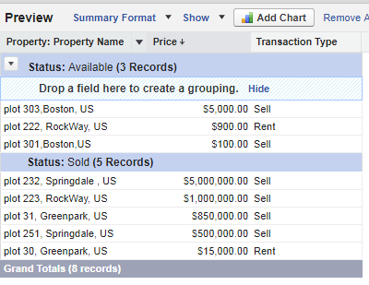

**3.Matrix:**

Matrix report is similar to summary report. In summary report grouping is done on row basis. Matrix report is used when there is a need for grouping in both rows and columns. Following is the screenshot of Matrix report.

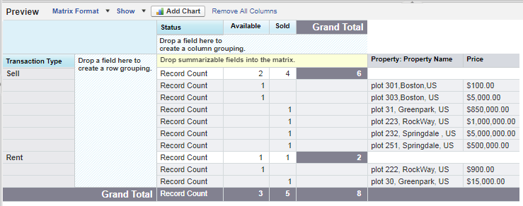

**4. Joined Reports:**

Joined reports are used to show and compare the data of one or more objects in a single report. Following is the screenshot of Joined report.

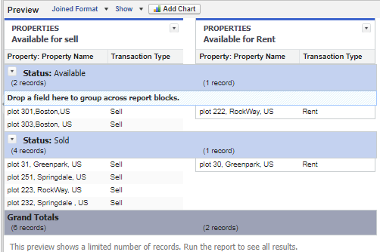

Following steps shows you how to create a Tabular report of “Sold properties based on price(in Descending Order)”

**Creating a Report in Salesforce:**

Navigate to ‘Reports’ tab and select New Report.

You will be redirected to the following screen where you can select the object you would like to create a report on. Here we are creating a report for a custom object ‘Property’. So, select ‘Property’ object.

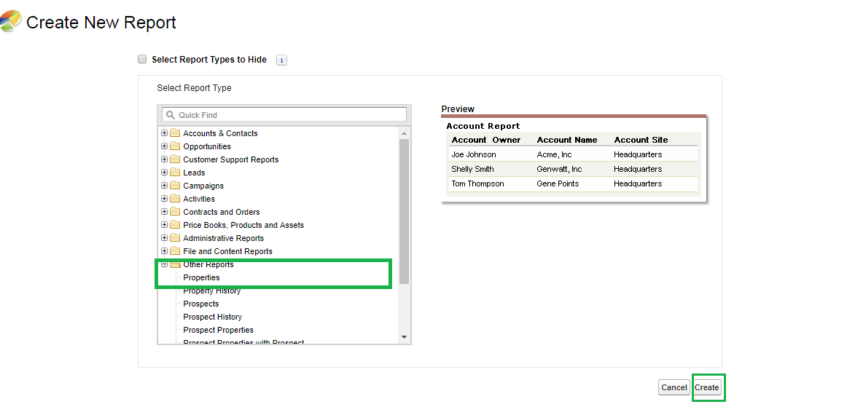

Click on ‘Create’ Button, which will redirects to the following page.

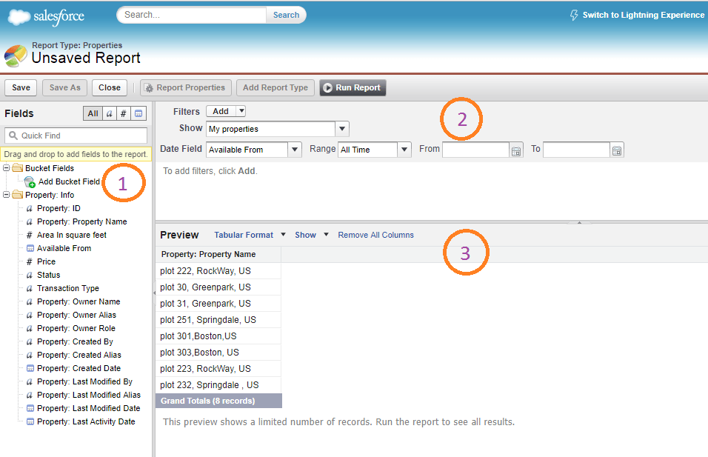

There are three sections in the above figure[](https://www.appseconnect.com/free-trial/)

**1. Fields:**

In this section, you will find all the fields related to ‘Property’ object. There are few buttons right to ‘Fields’ label which are used for grouping fields i.e.(‘**All**’- displays all fields, ‘***a***’-displays all text fields, ‘**#**’-displays all number fields, ‘**date**’-displays all date and time fields). You can also search for a specific field in the quick find box. You can drag and drop the fields into preview page(3) you want to report on. I’ve selected four fields: Property Name, Status, Price and Transaction Type as shown below

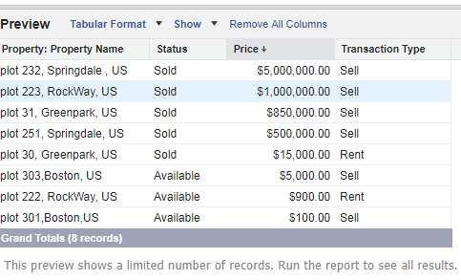

**2. Filters:**

As the name indicates it is used to filter the reports to show only the required data. Now, our requirement is to get a report on sold properties. Click on Add filter and select ‘**Status**’ field and select the value ‘**Sold**’ as shown below and click on ‘ok’.

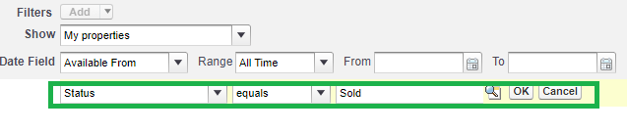

**3. Preview:**

In this section, you will get a preview of records as per the criteria. Our requirement is to create a tabular report for property object. So select “Tabular Format” in the preview section.

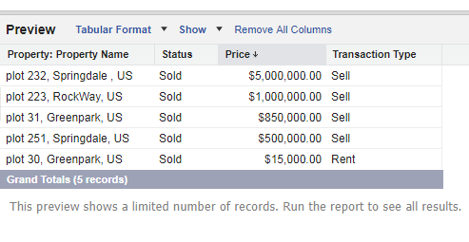

Once you select the ‘Report type’ Click on ‘**Save**’ button and save the report by selecting the folder in which you want to create the report as shown below.

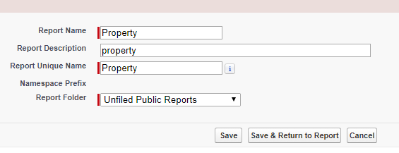

After saving the report, Open the ‘Property’ report and click on ‘RunReport’ to view the actual report as shown below. You can also customize and export the report generated.

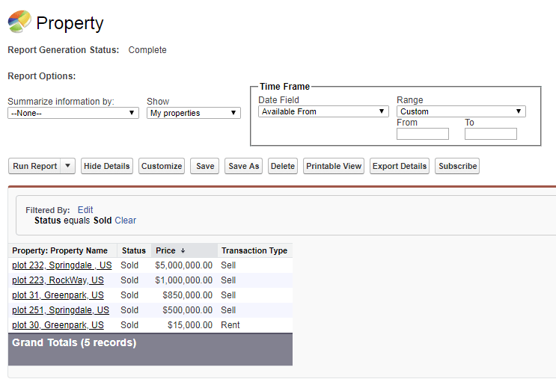

In this way, you can create “Tabular Report” for an object in Salesforce. Now we will see the ‘Property’ report in ‘DashBoard’. Now, what is Dashboard? It’s a new word we’re hearing right! Don’t worry we will have a quick look at what actually DashBoard is all about.[](https://www.appseconnect.com/free-trial/)

**What is Dashboard?**

A dashboard is a pictorial representation of data generated by reports. Visualization of data in pictorial format helps us to understand the stats in a quick manner. It lets you show the data from reports using different charts like Pie, Bar, Line, Donut charts etc. Each dashboard component has one report supply. The same report can be supplied to different dashboard components. Now, we will create a Dashboard for the ‘Property Report’ we have created.

**Creating Dashboard in Salesforce:**

Goto ‘Reports’ tab and click on new dashboard button. You will be redirected to the following page.

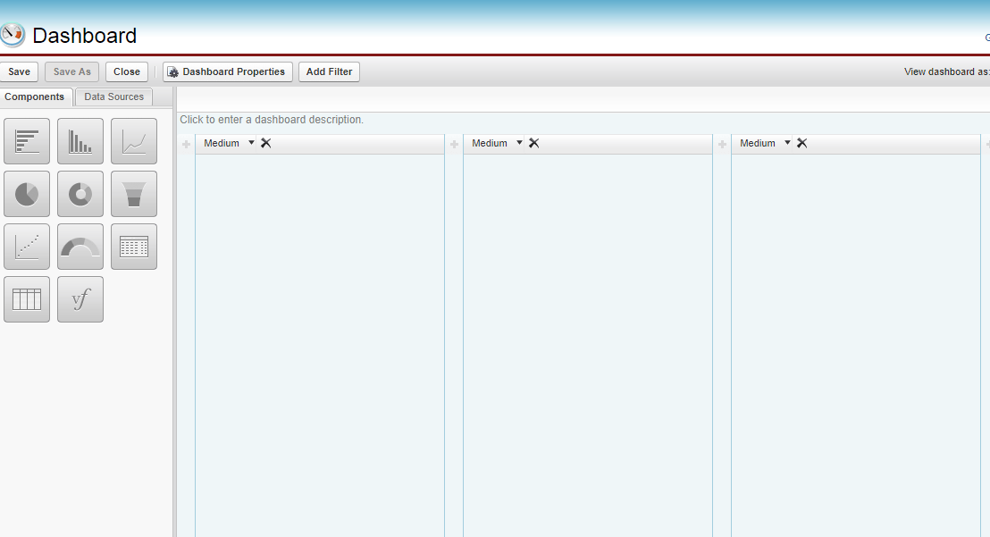

Dashboard components can be selected by just dragging and dropping them into dashboard layout.

**Note:**Salesforce won’t allow you to create Dashboard with ‘Tabular Format’ unless you apply “Row Limit” and “Dashboard settings” for the report. Navigate to ‘Property’ report and add Row limit as shown below and click on save button.

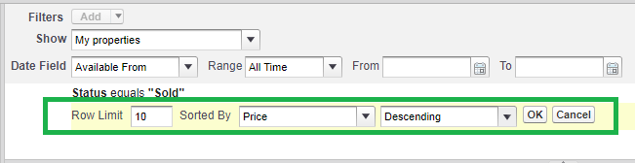

Now navigate to Reports ->Property report->Dashboard settings ->choose Name, value to use in dashboard tables and charts as shown below.

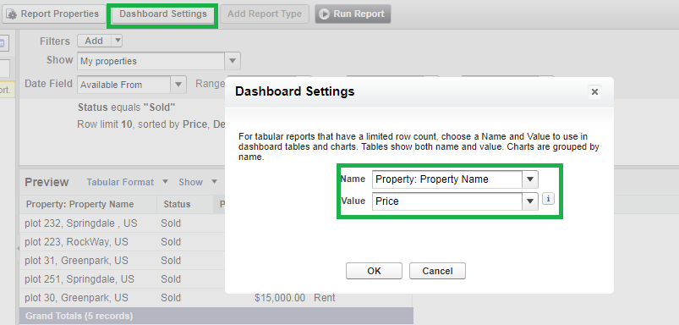

After completing the above two steps, go to dashboard section and select the components you want to create a dashboard for. Here I’m selecting multiple components as shown below .

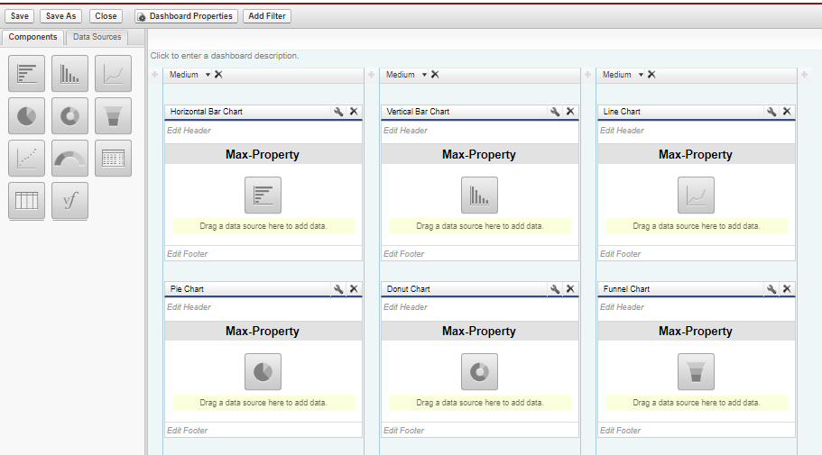

Now go to “Data Sources”.

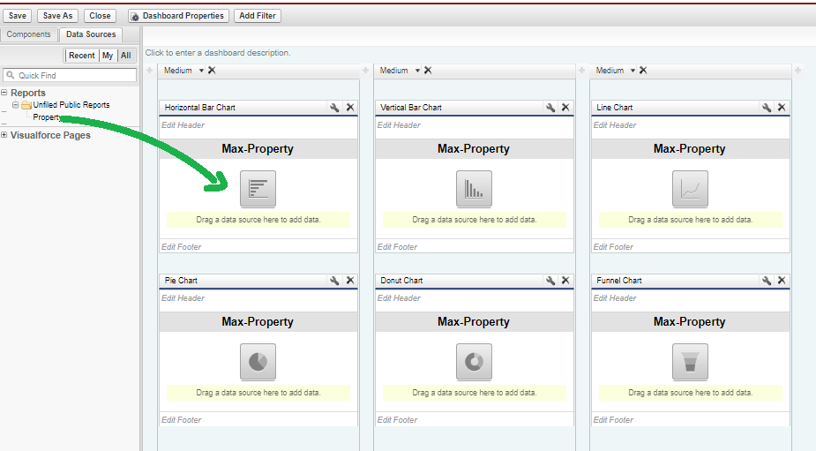

Drag and drop the ‘property’ report for each dashboard component and click on save button to save the dashboard. Now click on ‘Dashboard’ tab  to see the pictorial representation of ‘Property’ report as below

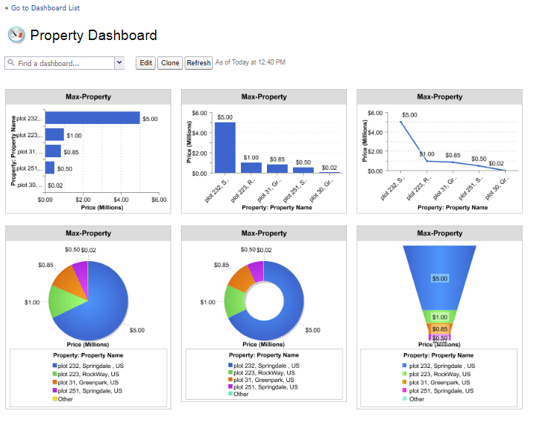

In this way you can create dashboards in Salesforce.

**Conclusion:**

Every business needs clear ‘Reports’ and ‘Dashboards’ to get insights from them for better understanding and forecasting a Business process. These Reports and Dashboards will be helpful for their Business enhancement.

Now, you can easily [**integrate your Salesforce CRM with the back-end ERP system**](https://www.appseconnect.com/salesforce-crm-integrations/) to automate the business process!

# Duplicate Rules

A duplicate rule defines what happens when a user views a record with duplicates or starts creating a duplicate record. Salesforce provides standard duplicate rules for business and person accounts, contacts, and leads. You can also create duplicate rules.

1. Select the actions you want to occur when a user starts creating a duplicate.

The default actions are to alert users when they start to create a duplicate, and report on duplicates created when users create or edit records. You can customize the provided alert text.

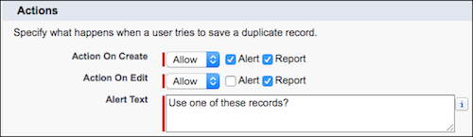

1. In the Matching Rules section, select the object to compare records on. Then select the matching rule that determines how records are identified as duplicates.

The list includes all available matching rules for the selected object.

Tip

TIP

If you want to use a new custom matching rule, we recommend that you finish creating your duplicate rule before selecting **Create New Matching Rule**. Then create and activate the matching rule. The new matching rule is automatically associated with the duplicate rule.

1. Select the field mapping for each matching rule, if needed.

If the matching rule compares records on two different objects or uses custom fields, consider the following:

* + Decide how you want to compare the fields on the first object to the fields on the second object. For example, map a custom field called Work Email to the standard Email field.
  + If two text fields with different maximum lengths are compared, data in the fields can be truncated before a match is determined.

1. If you want your duplicate rule to run only when specific conditions are met, enter the conditions.

For example, the rule runs only if a user with a certain profile or role creates a record. Or set a condition for the rule to run only if the record includes a specific country, state, or province.

1. Save and activate the rule.

For the activation to succeed, all associated matching rules must be active.

1. If you have more than one active duplicate rule for a particular object, consider adjusting the order in which the rules are processed. Reorder rules by clicking **Reorder** on any rule’s detail page.

Tip

Leads - People who is interested in your company to do business with or involved in a business which your company can offer to him. Yet, but have not qualified them. Unsure if they're going to buy from you. People you don't have a relationship with yet.   
For example: Visiting cards which you get on conference or trade show.   
   
Leads converts into Contact and Account  
Contact - Someone you have a business relationship with, someone you know. Possibly has bought from you in the past.  
  
Account - A business entity. Contacts work for Accounts.  
  
Opportunities - Sales events related to an Account and one or more Contacts.  
Opportunity is when you had a discussion with a contact and you think yes there is some connection between your offerings to the person you talked with. You create an opportunity. Opportunity is basically putting together  
  
You can not create an Opportunity without converting a lead into Account and Contact.